Contents

Register as a new trader 2

Register with invalid details 3

Register with valid details 4

E-mail Verification 5

Trader login with valid details 6

Trader login with invalid details 7

Add new products 8

Update existing product details 9

Delete existing product 10

Logout 11

View Profile 11

Update Profile 12

## Register as a new trader

Expected Result: Trader registration form is displayed

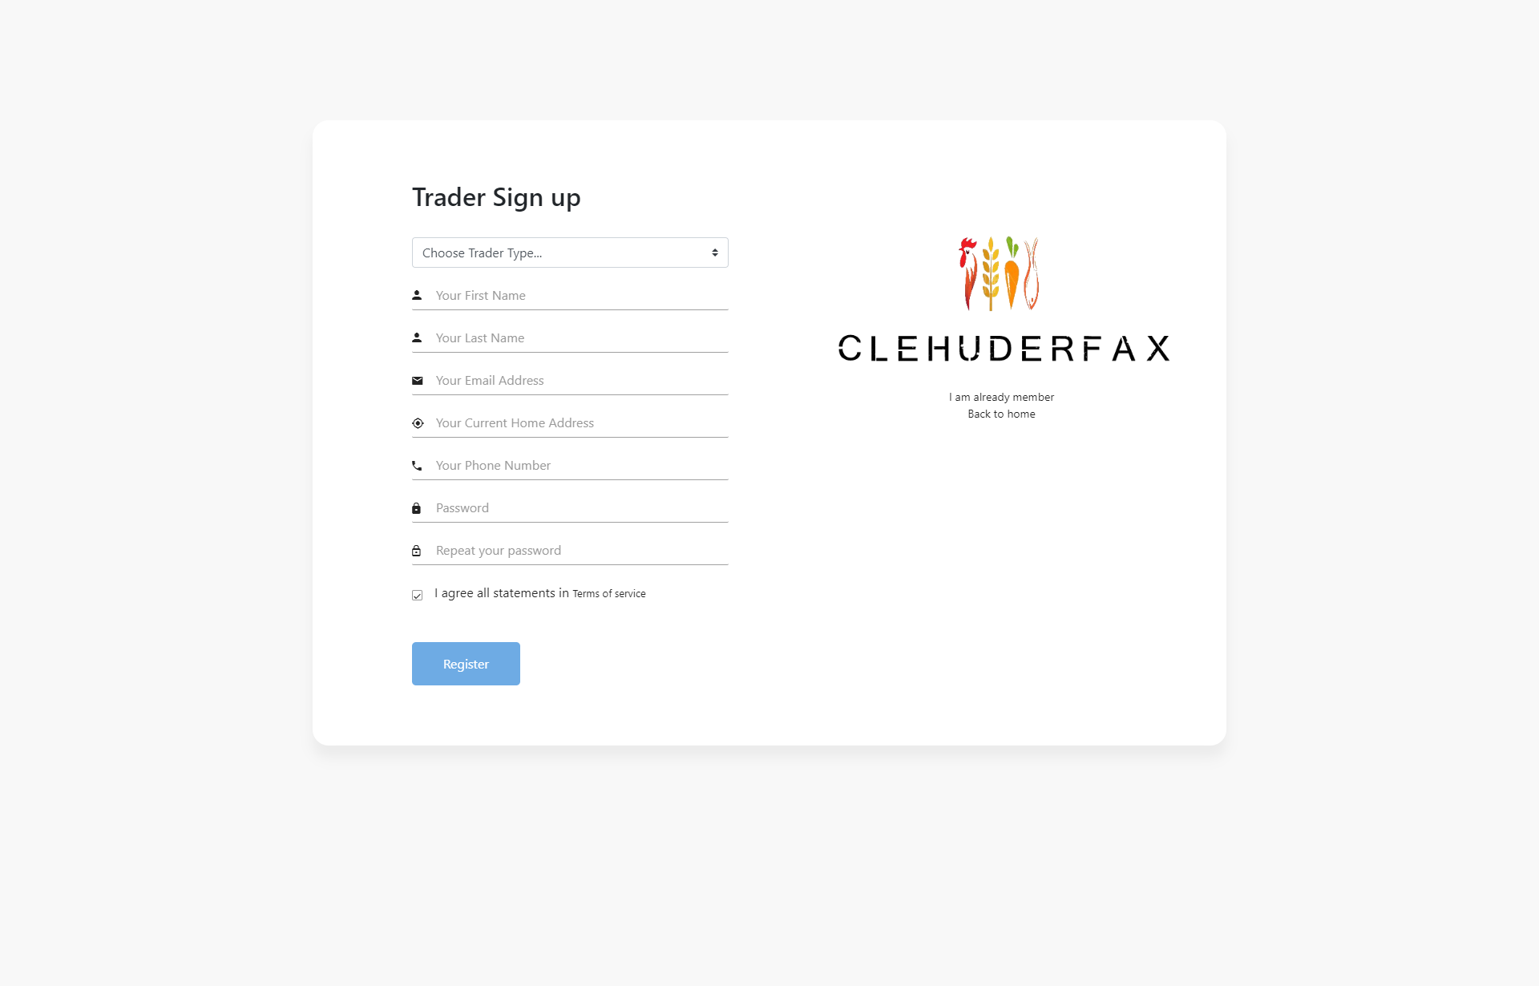

## Register with invalid details

Expected Result: Access to registration denied

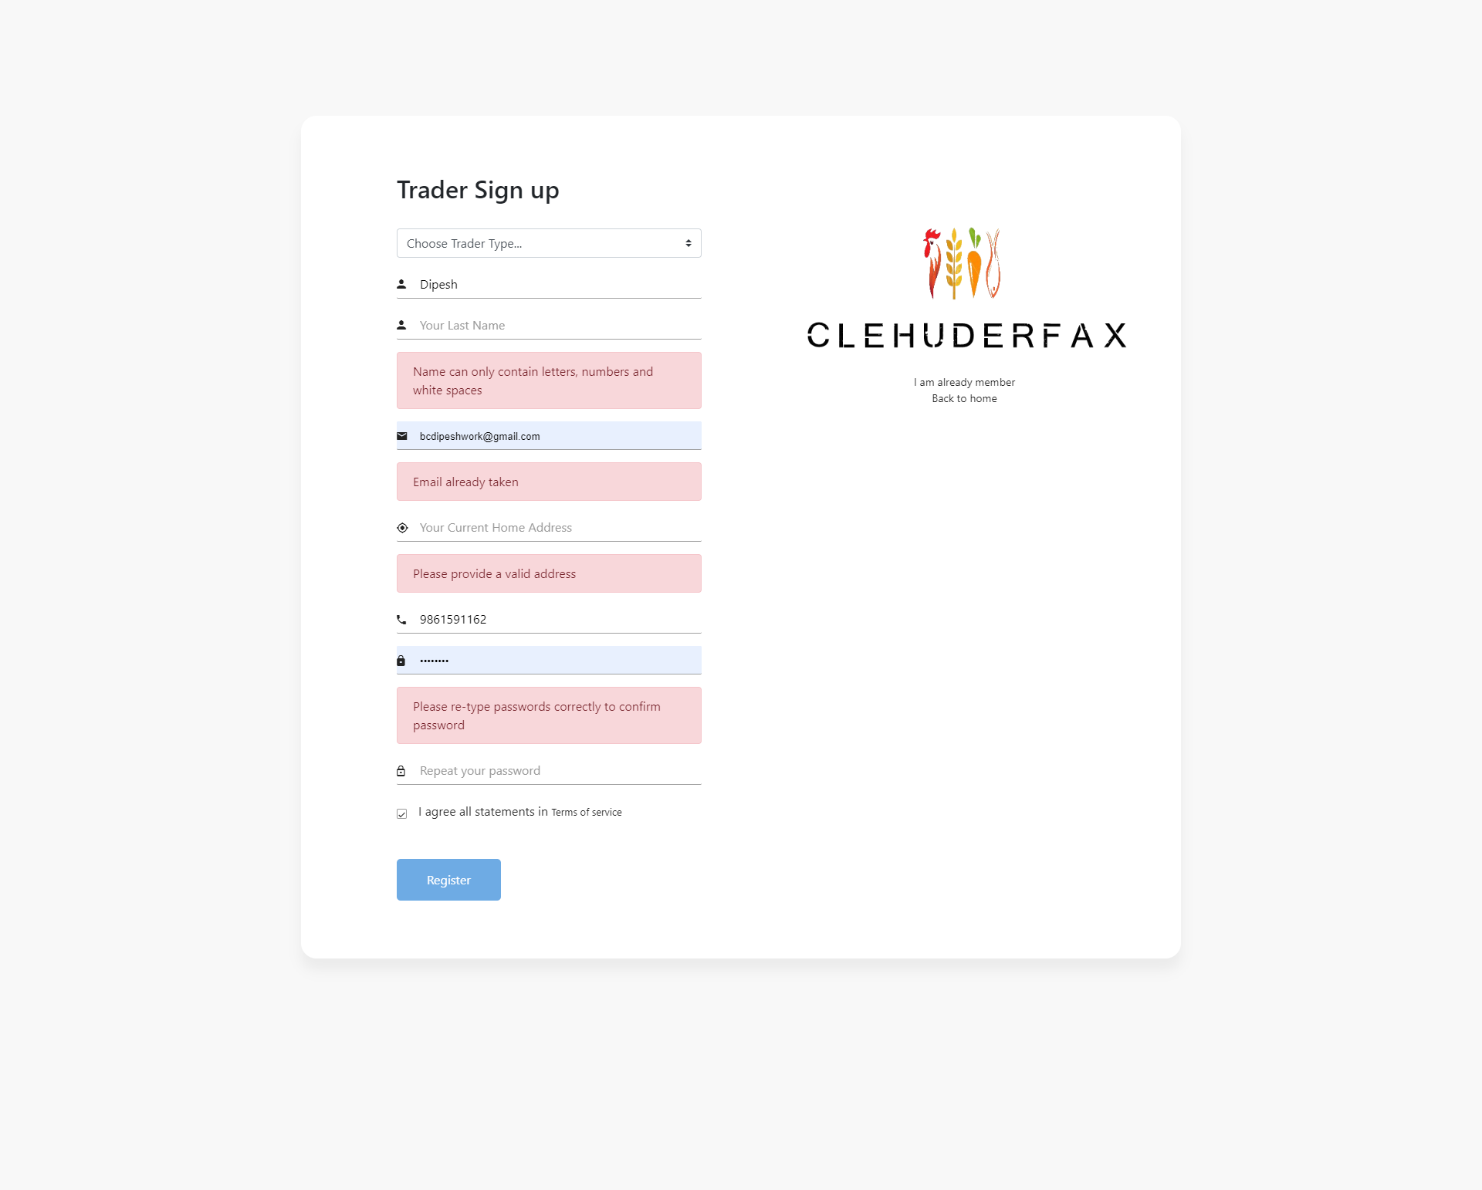

## Register with valid details

Expected Result: Registration process is successful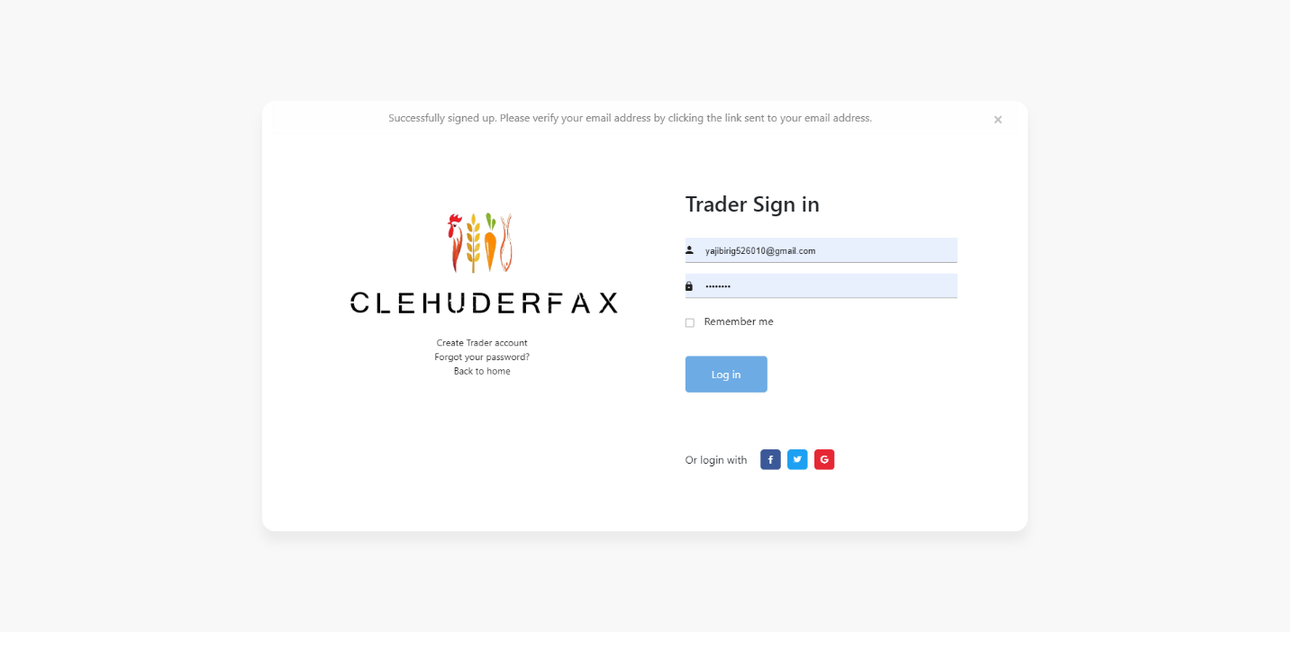

## E-mail Verification

Expected Result: Trader is verified via e-mail

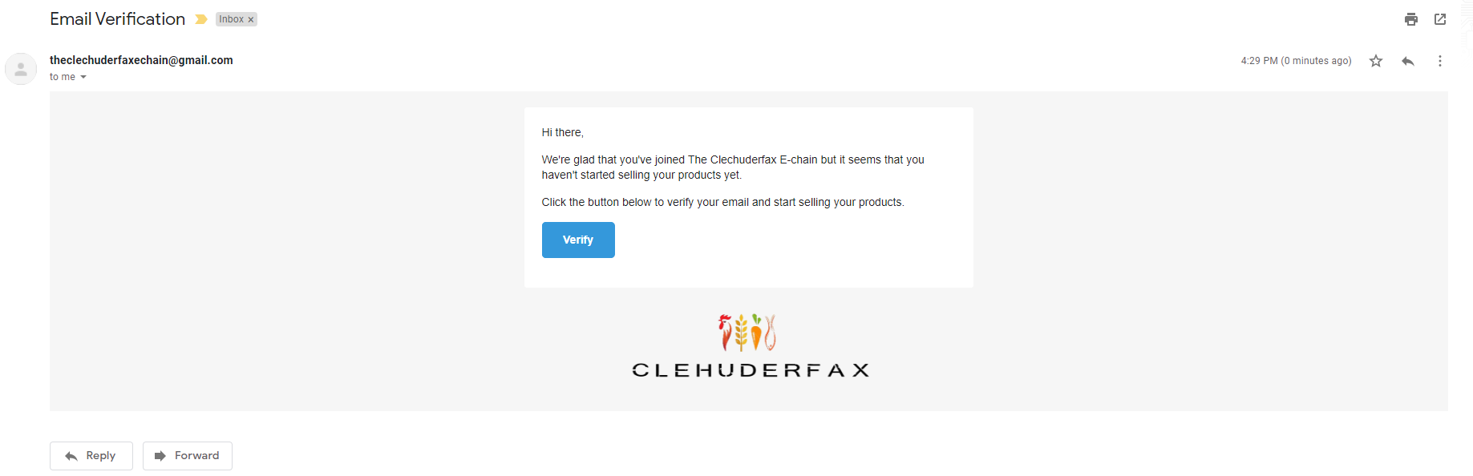

## Trader login with valid details

Expected Result: Trader is successfully logged in after email verification.

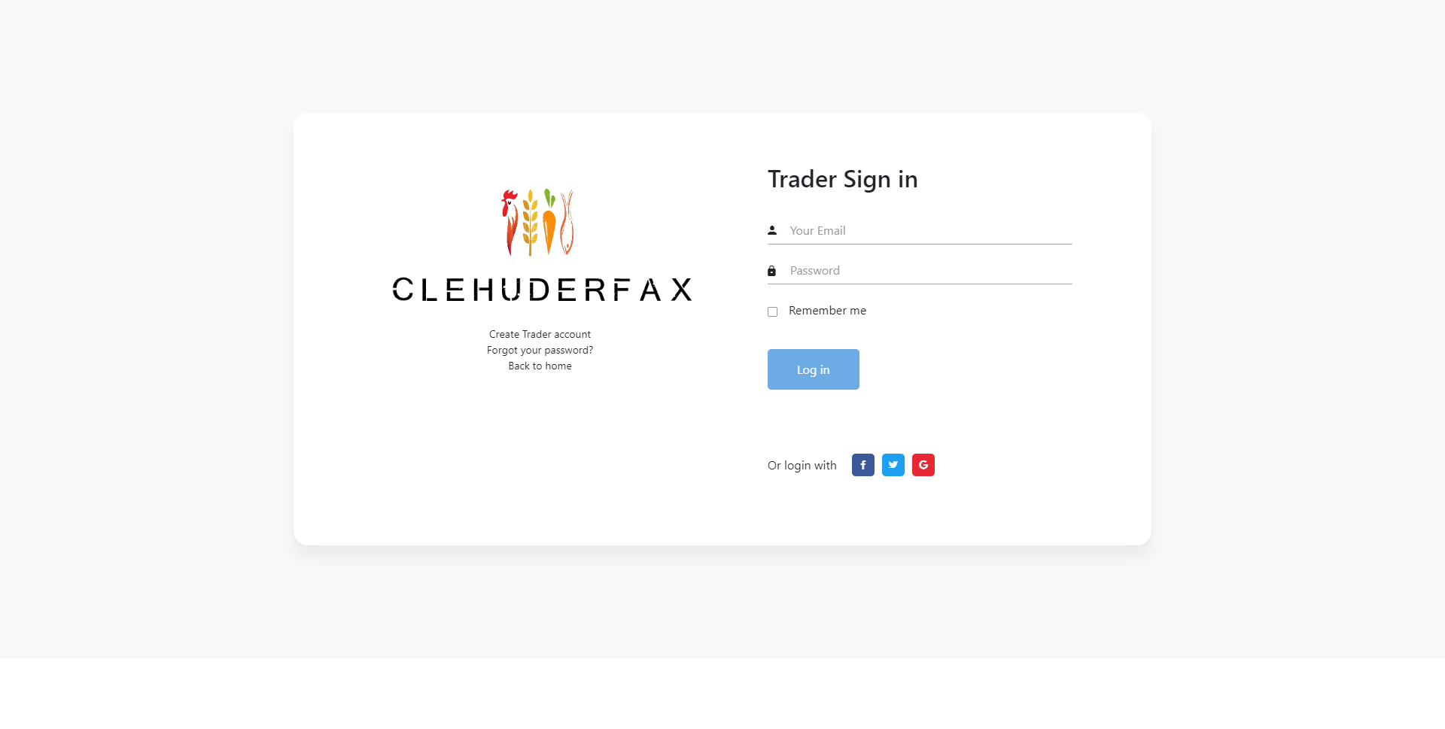

## Trader login with invalid details

Expected Result: Access denied

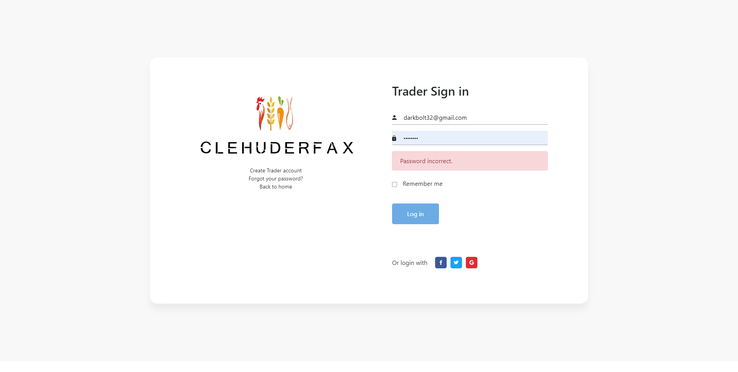

## Add new products

Expected Result: Trader can add new products

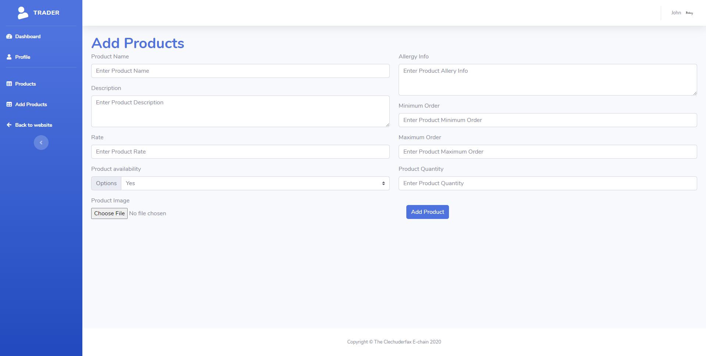

## Update existing product details

Expected Result: Trader can update details of existing product

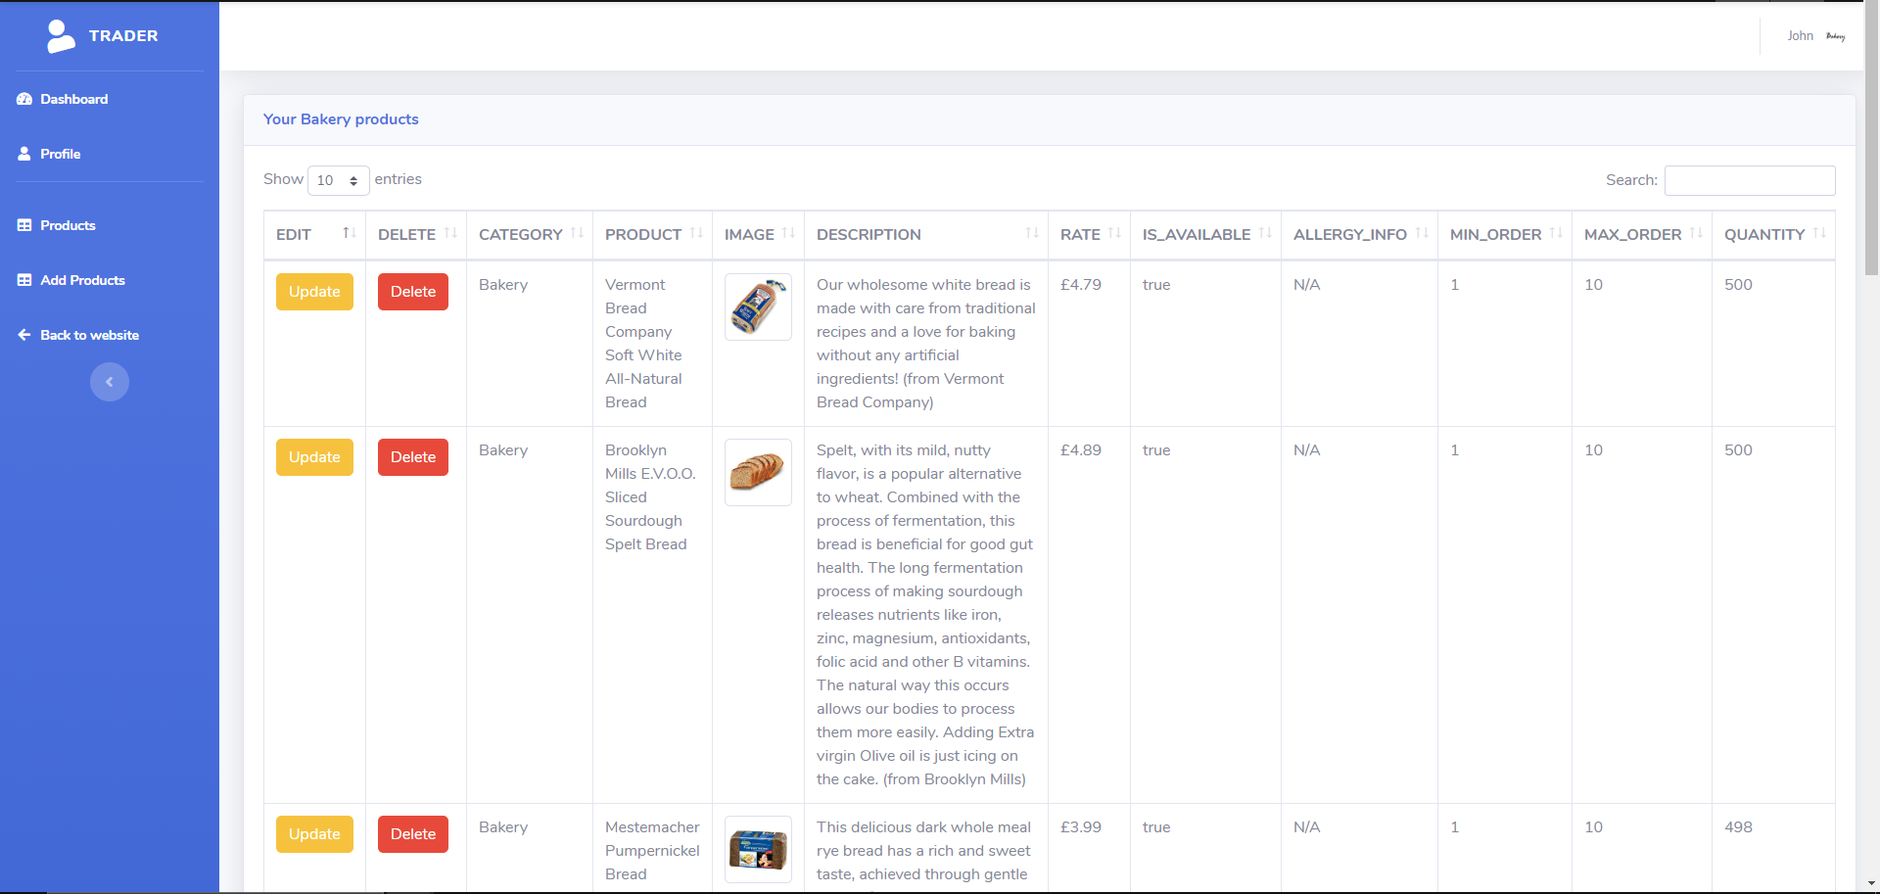

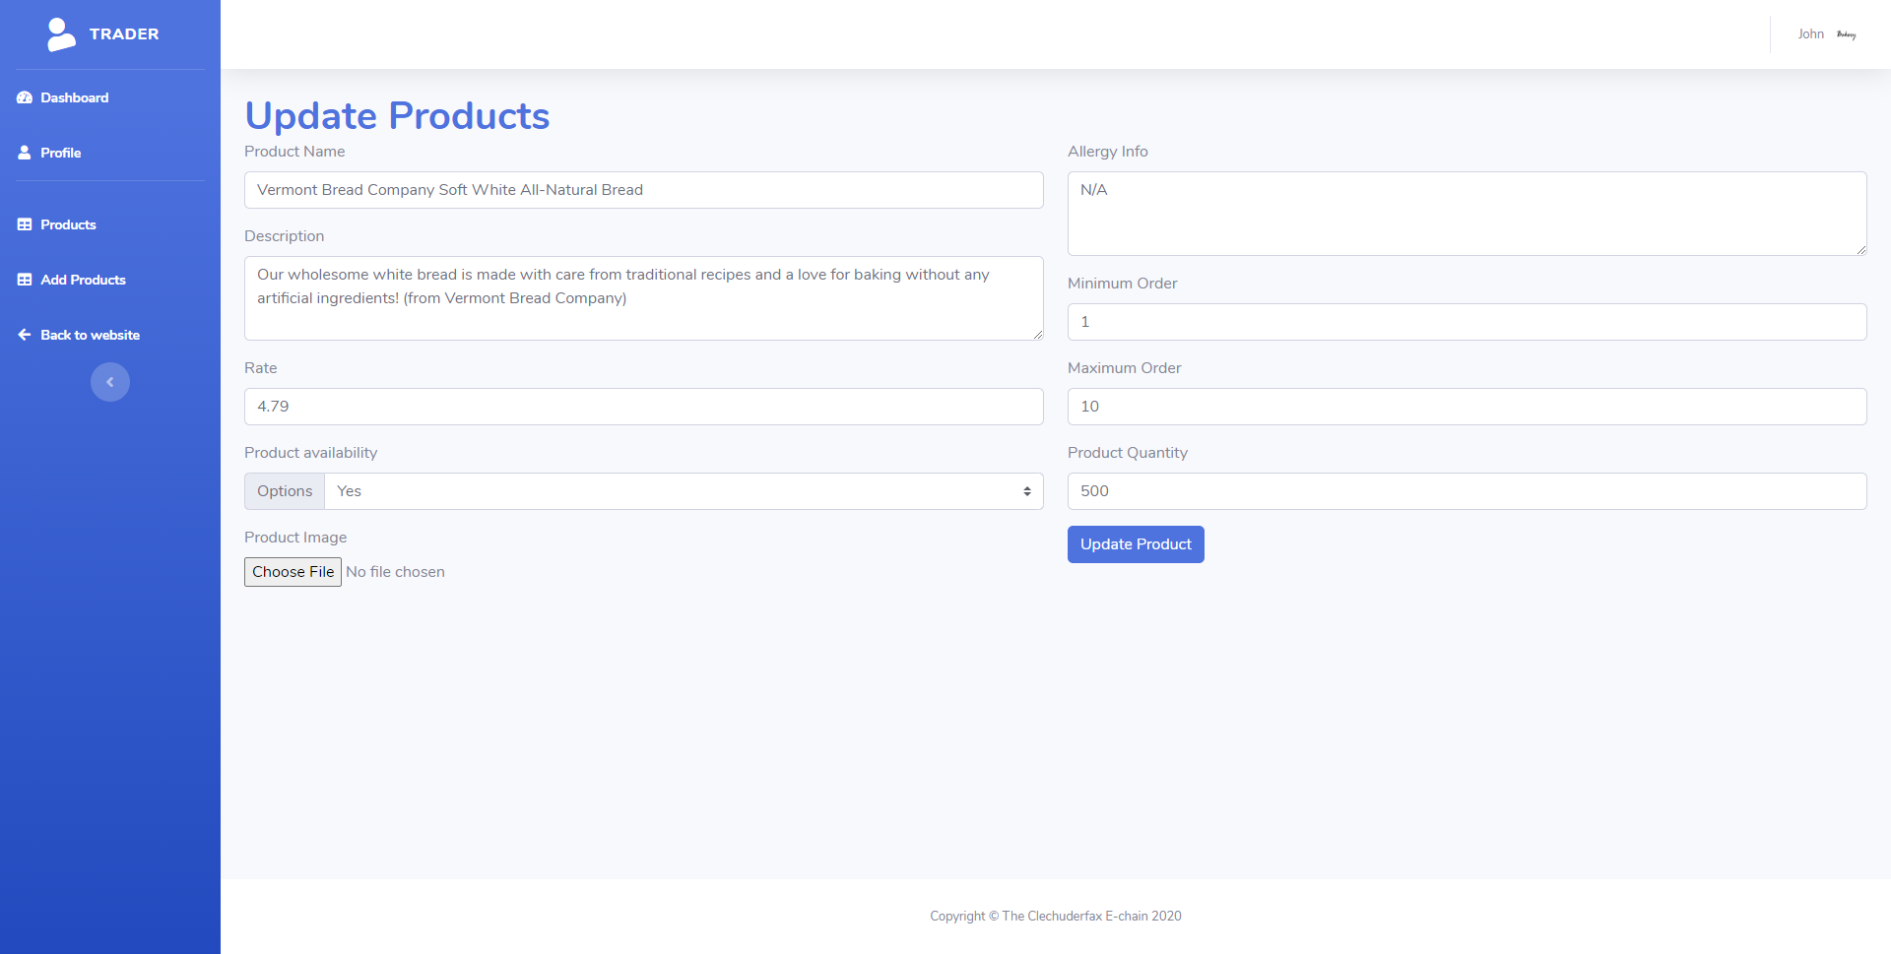

## Delete existing product

Expected Result: Trader can delete product

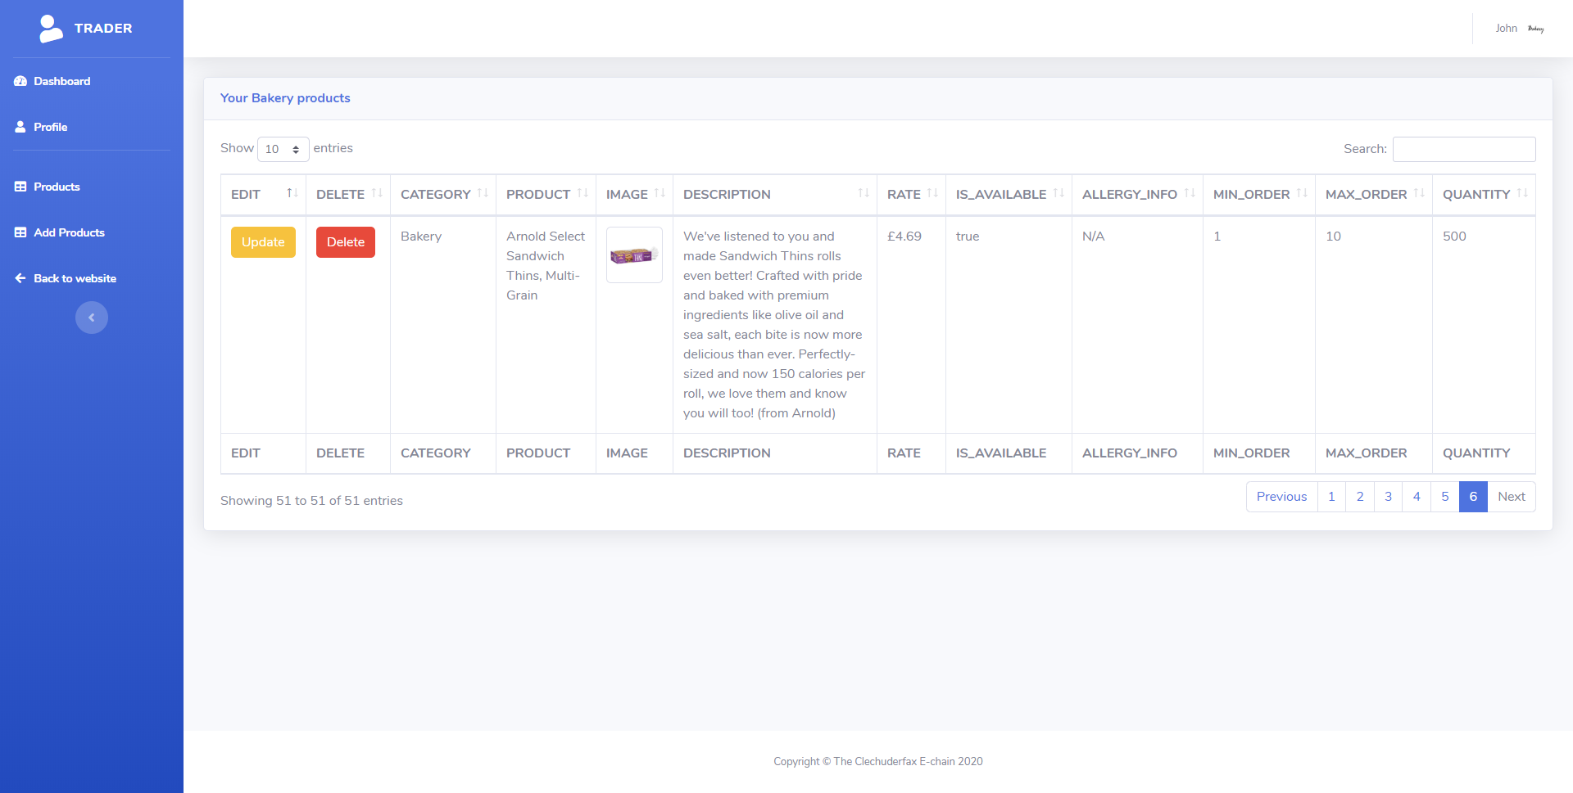

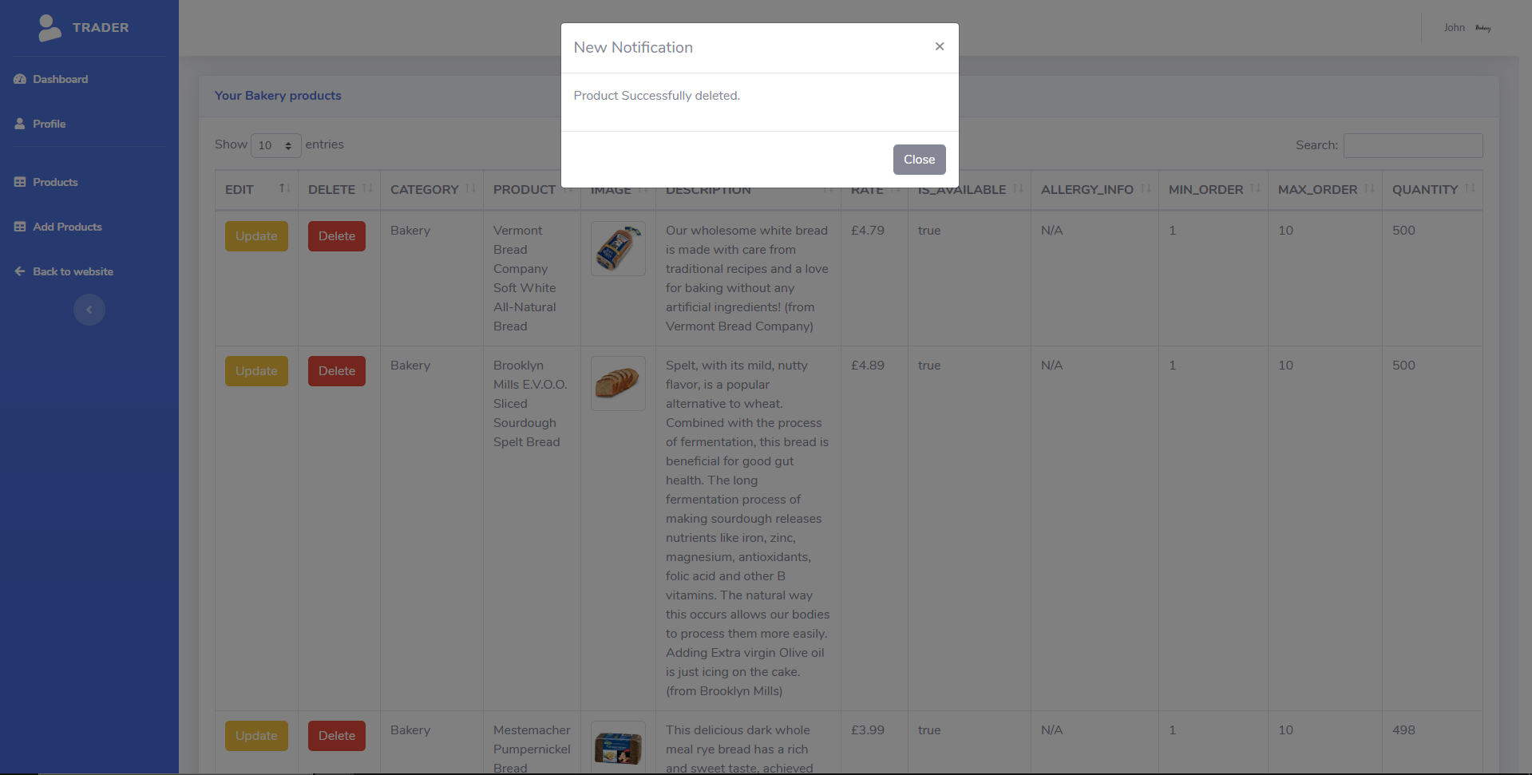

## Logout

Expected Result: Home Page is displayed with logout notification.

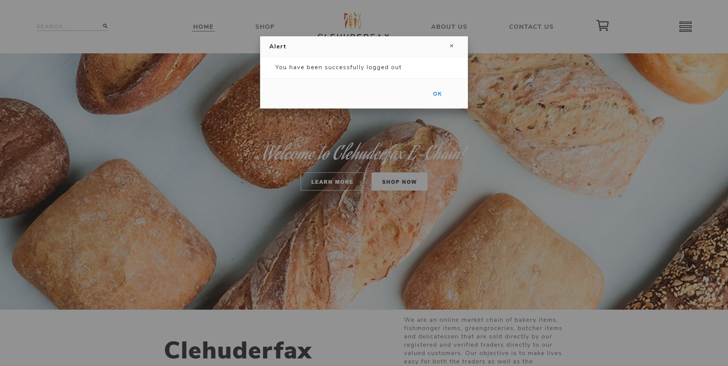

## View Profile

Expected Result: Trader can view their profile

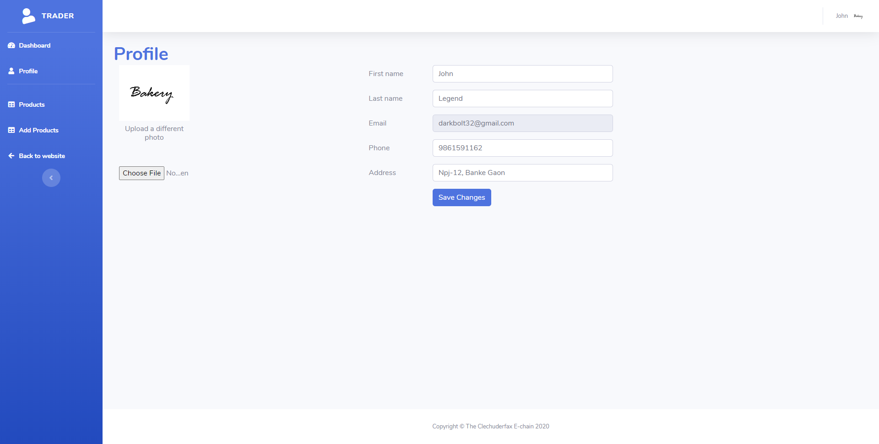

## Update Profile

Expected Result: Trader can edit their profile

